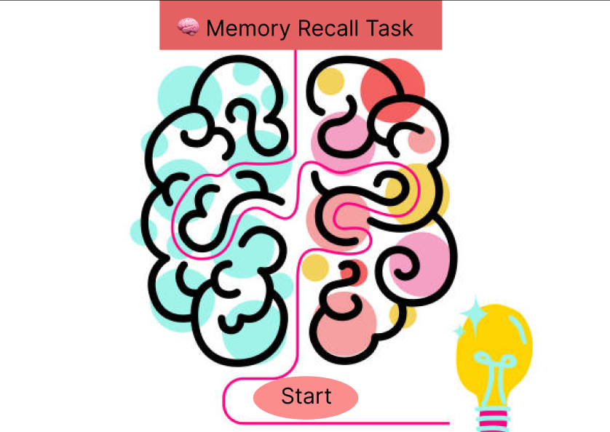

Title: Memory Recall Task
Visuals: Abstract brain illustration, lightbulb, and a start button.
Purpose:
- Introduce the task in a fun, engaging way.
- Encourage participation through vibrant visuals.
User Instruction:
- Click the "Start" button to begin the memory game.



Title: You will be shown groups of pictures
Visuals: Icons (question mark, bulb, chat, magnifying glass)
Purpose:
- Explain the upcoming memory challenge.
- Set expectations for what’s going to happen.
User Instruction:
- Look at the group of images carefully.
- You’ll have 5 seconds to memorize them.

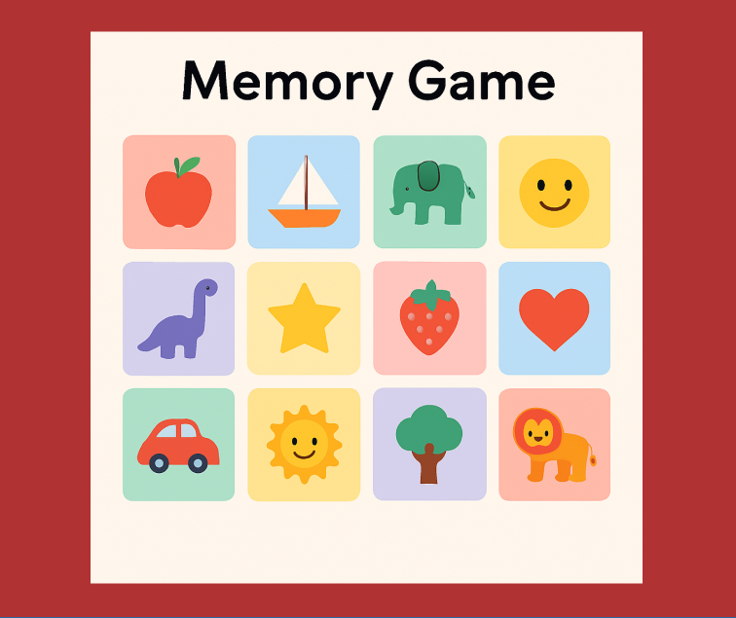

Title: Memory Game
Visuals: Grid of 12 colorful icons
Purpose:
- Present a set of distinct, easily recognizable images.
- Test short-term visual memory.
User Instruction:
- Observe and try to memorize as many icons as possible within 5 seconds.
- No interactions needed here—just observe.

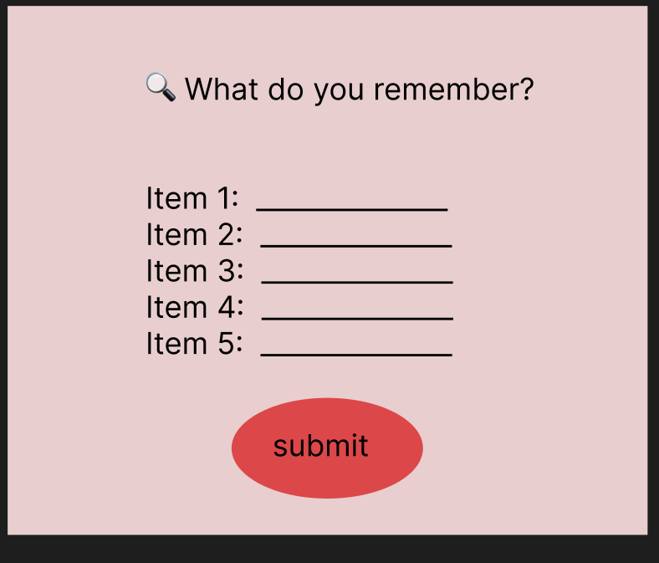

Title: What do you remember?
Visuals: Input fields for 5 items, and a red Submit button.
Purpose:
- Let users recall and input what they remember from the image set.
User Instruction:
- Type the names of 5 items you remember seeing.
- Click Submit once done.

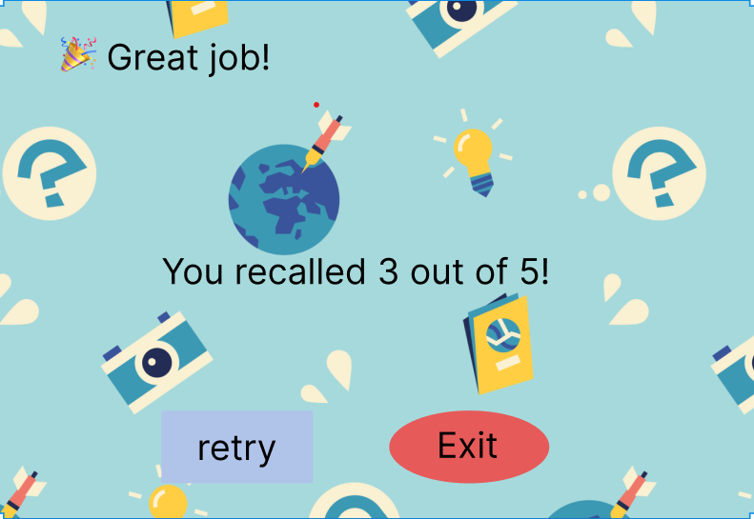

Title: Great job!
Message: You recalled X out of 5!
Visuals: Celebration background, Retry and Exit buttons.
Purpose:
- Give feedback and results.
- Encourage retry or end the task.
User Instruction:
- Click Retry to try the task again.
- Click Exit to close the task.

